## Q.1. Write a program to convert seconds into hour:minute:second format

Test cases:

1. Input: 7845

Output: 2 Hours 10 Minutes 45 Seconds

1. Input: 9871

Output: 2 Hours 45 Minutes 31 Seconds

Refute Test cases:

1. Input: 287.8

Output: ValueError: invalid literal for int() with base 10: '287.8'

1. Input: 2673seconds

Output: ValueError: invalid literal for int() with base 10: '2673seconds'

In Python, since we are taking input for int data type for seconds, its unable to read values of string or float data type.

Hence it throws a ValueError

**Program:**

seconds=int(input("Enter seconds: "))

hrs=int(seconds/3600)

mins=int(seconds%3600/60)

sec= int(seconds%3600%60)

print("{:d} Hours : {:d} Minutes : {:d} Seconds".format(hrs,mins,sec))

**Output:**

**Test Cases :**

Input 1 :



Input 2 :



**Refute Test Cases :**

Input 1 :

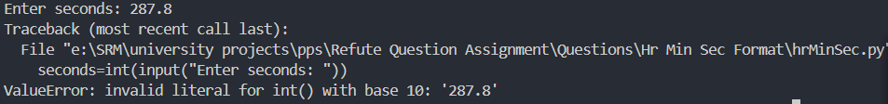

Input 2 :

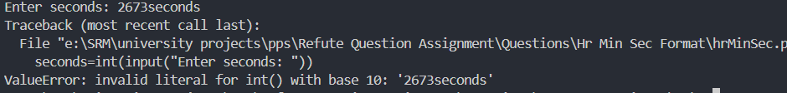

Q.2. Write a program to count the numbers between A and B which is multiple of C

**Test cases:**

1. **Input:**

123 456 100

**Output:**

3

1. **Input:**

1 5 10

**Output:**

-1

**Refute Test cases:**

1. **Input:**

i7 25 65

Output:

ValueError: invalid literal for int() with base 10: 'i7'

1. **Input:**

Hello7

Output:

ValueError: invalid literal for int() with base 10: 'Hello7'

Here, since one of the inputs is string, its unable to convert to integer as the value taking input is only accepting integer values.

Hence it throws a ValueError.

**Program:**

A,B,C=input().split()

A,B,C=int(A),int(B),int(C)

c=0

for i in range(A,B+1,1): #range from A -> B

if(i%C==0 or i%C==0): #check for numbers divisible by C -> multiple of C

c+=1

if(c==0):

print(-1)

else:

print(c)

**Output:**

**Test Cases :**

Input 1 :



Input 2 :



**Refute Test Cases :**

Input 1 :

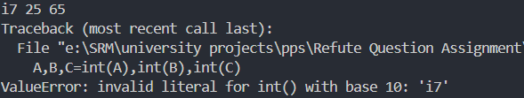

Input 2 :

